Team Captain Toolkit
Wellspring Multi-Service Centers

Contents:

Getting Started – First Steps on Your Fundraising Journey – Claim your page...............................3

Getting Started – First Steps on Your Fundraising Journey – Create a Team page………………………4

Email template: SAMPLE EMAIL – FOLLOW UP EMAIL TO TEAM MEMBERS ………………………………6

Email template: FUNDRAISING APPEAL LETTER ……………………….………………………………………….…….7

Email template: THANKING YOUR SUPPORTERS ............................................................................8

Who should I ask............................................................................................................................ 9

9 Steps to raise $2,000..................................................................................................................10

Your Offline donations………………………………………………………………………………..…………………………….11

Sample posts……………………………………………………………………………………………………………………………..12

Final thoughts……………………………………………………………………………………………………………………………13

Support……………………………………………………………………………………………………………………………………..14
Get Started – First Steps on Your Fundraising Journey
Blackbaud Peer-to-Peer Fundraising, powered by JustGiving has been helping people just like you connect with and support the causes they love. And in helping these wonderful people, we’ve learned that giving isn’t just about money. You give your time, your voice, your energy, your heart … yourself, all of which makes a huge difference to the causes you care about.
Take advantage of all the resources available through Blackbaud Peer-to-Peer Fundraising, powered by JustGiving to get started with your fundraising journey. Begin showing your support and passion for Wellspring now!
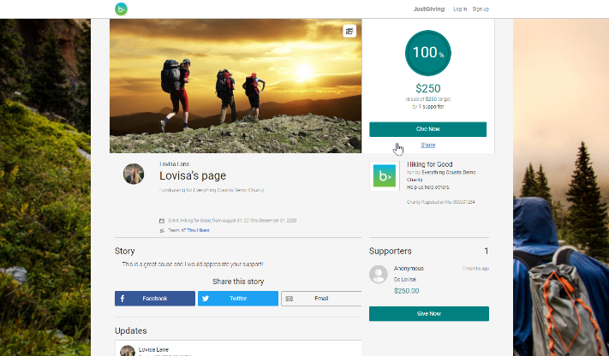
1. CLAIM YOUR PERSONAL PAGE
You should have received an email from your organization’s admin inviting you to claim your personal and team fundraising page. If you haven’t, email Jessie Pilewski, Advancement Coordinator (jessie@wellspringmultiservice.org) for further help.
- Click on the ‘Start Fundraising’ button on your organization’s campaign
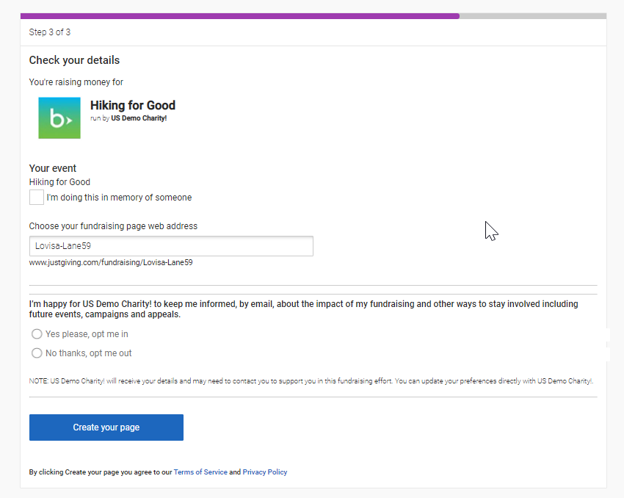
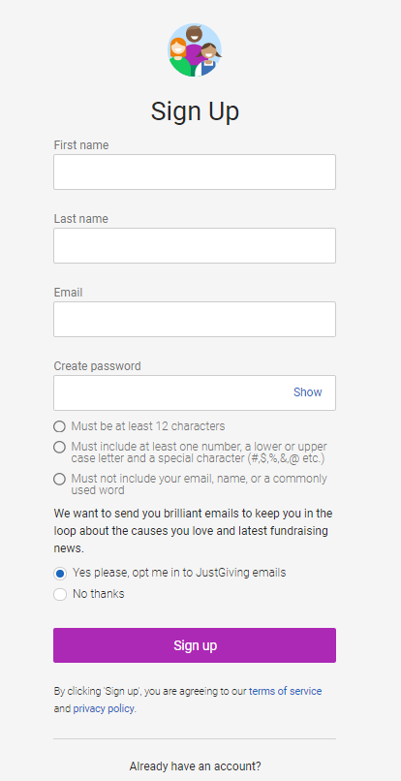
2. Sign-Up for a JustGiving fundraising account. Add your
- First name
- Last name
- Email
- Create a password
3. Check your details
4. Choose your Fundraising URL
5. Click ‘Create your page’

2. CREATE YOUR TEAM OFF YOUR FUNDRAISING PAGE
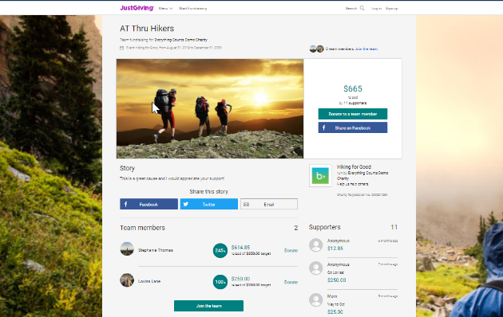
Our Team Pages allow you and your friends to join your individual fundraising pages together to contribute to an overall total.
They're great if you want to raise money separately whilst still contributing to a larger team goal.
The page will list everyone’s individual page, as well as the charity you’re raising money for and the collective total you’ve raised together.

How to create a team page:
- Create a fundraising page that you want connected to a team (process mentioned above)
- On your page click the link called 'create a team'
- Next up, you can give your team a name
- You'll be asked to confirm the charity you're raising money for and the event you’re participating in
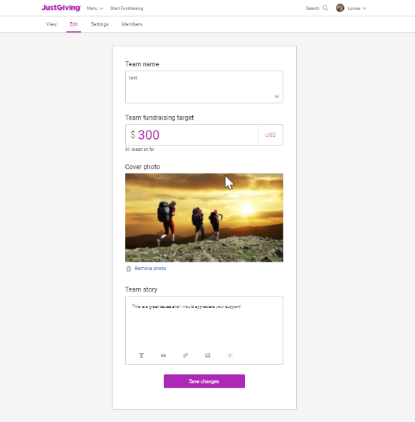
- Provide the story behind your reason to fundraise together and add a cover photo
- Set the team’s fundraising target
- You can set targets for individual team member's by using the drop down
- Choose your team's web address and hit 'create a team'

TIP: Click here to learn how to edit your team

Congratulations! You created your fundraising page and team on Blackbaud Peer-to-Peer Fundraising, powered by JustGiving.

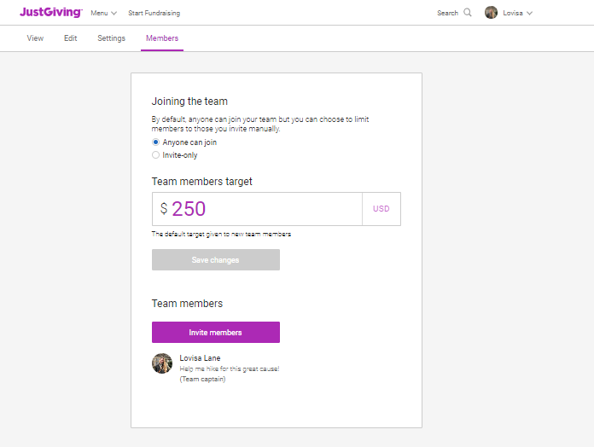
3. INVITE YOUR FRIENDS TO JOIN YOUR TEAM
Once you’ve set up a Team Page, you can update it by clicking 'edit' at the top of the page. You can update:
- The title of your Team Page
- Your target
- Your cover photo
- Your team story

How can I manage who's in my Team?
Click on the member’s tab at the top of your team page.
- From here you can make your team page open for anyone to join
- You can make your team accessible by invitation only
- You can invite new members
- You can remove team members

Prefer to fundraise as a group on the same page?
If you and your team mates are fundraising for the same charity and would prefer to use the same page, create a regular fundraising page and list all of your names in the story section. Choose a web address that reflects your team name, you could also update the name in the account to reflect your team name.

You are stronger together! In addition to fundraising together (or apart if you’re in different cities), encouraging each other to fundraise, connecting your fundraising pages, and becoming a team provides even more inspiration and motivation for everyone including your donors!

SAMPLE EMAIL – FOLLOW UP EMAIL TO TEAM MEMBERS
TARGET AUDIENCE
Here is an email template you can send to your team members who have not created their fundraising page yet.

Simply insert your team and personal information where applicable.

SUBJECT LINE
We’re fundraising for Wellspring Multi-Service Centers.

EMAIL BODY COPY
Dear [Name],
Thank you for joining our fundraising team, [Team Name]. Together, we are going to raise $[Fundraising Goal], as a team. To meet our goal, each person will need to raise approximately $[Your fundraising goal/# of team members].
I can’t wait to get started. By now you should have received an invitation to claim our fundraising team and create your personal fundraising page.
If you didn’t get that invitation, you can also simply click here [Insert team page link] and click “Join Team.”
THEN...
1. Update your page with your photo and personal story.
2. Share your link with friends and family.
3. Be awesome. And remember to say thanks to your donors.
Let’s do this! Here we come!

Kind regards,
[Your Name]

SAMPLE EMAIL – FUNDRAISING APPEAL LETTER
SUBJECT LINE
I’m fundraising! Join me to support Wellspring Multi-Service Centers.

EMAIL BODY COPY
Dear [Name],
I’ve made a commitment to do something incredible this year. I’ve teamed up with some of my closest friends and a few strangers to fundraising for [organization’s name].
[Your email can include a short history of your passion for this cause and/or your involvement with the organization.]
Together, our team of [number of team members] has committed to raise [goal] for Wellspring.
Wellspring Multi-Service Centers’ mission is to provide support and skills to people facing challenges to their well-being in order to help them achieve independence and self-sufficiency.
A private, 501(c)3, multi-service organization with two locations on Boston’s South Shore, Wellspring serves individuals and families throughout the region. Our programs, available in our Hull and Weymouth locations, reach beyond providing emergency services and help people become more independent, productive members of their communities.
I hope you will join me in this adventure. Please visit my fundraising page and consider donating $25 or more. I'd appreciate any support you want to provide.
[Insert page link]
With the deepest gratitude,
[Your Name]
TARGET AUDIENCE
Use this email to send to your friends, family, colleagues, and personal network, asking for their support. Share it with your team members so they can use it too. Customize with your personal information.

SAMPLE EMAIL – THANKING YOUR SUPPORTERS
TARGET AUDIENCE
Here is a sample email you can send to your donors to thank them for their support. Simply insert your team and personal information where applicable.
SUBJECT LINE
Thank you for your donation!

EMAIL BODY COPY
Dear [Name],
Thank you for making a donation toward my fundraising goal to my [campaign name] campaign!
[Insert something specific about why you're grateful or how the donation is being used by [your chosen charity’s name.]
Check out how close I am to reaching my fundraising goal by visiting my personal Supporter Page:
[Insert page link]
Thanks again for your donation.
Sincerely,
[Your Name]

WHO SHOULD I ASK TO DONATE?
These are people in your life who may be as passionate as you to support your charity’s cause. Use this list to identify all the individuals who could be donors and support you and your team in reaching your fundraising goal.

KNOW PEOPLE AT...
Camp:
Church, Synagogue, Mosque, Temple, etc.:
Clinic:
Golf Course:
Health Club:
School- High School:
School - College:
Volunteer Group:

OTHER PEOPLE...
Bank Teller:
Children's Friends' Parents:
Facebook "Friends":
Fraternity or Sorority Friends:
Mailman:
My Parent's Friends:
People From Past Jobs:
Play Sports With:
WHO IS MY...
Accountant:
Spin/Gym Instructor:
Architect:
Attorney:
Bartender:
Beautician:
Chiropractor:
Dentist:
Electrician:
Financial Planner:
Nurse:
Nutritionist:
Optometrist:
Physical Therapist:
Physician:
Veterinarian:

9 EASY STEPS TO RAISE $2,000
Whether you want to set a team goal of raising $2,000 together or be bold and raise $2,000 on your own, follow these 9 easy steps to raise your first $2,000.
TWO STEPS TO RAISE $168
Set a fundraising goal of $500 and make a donation yourself! Fundraising pages that receive at least one donation within 48 hours raise more. Being the first to donate to your campaign shows commitment, dedication and sets the tone for your supporters.
1) Donate to yourself. It starts with you!................................................................................................. $58
2) Post your supporter page link and ask your 10 of your Facebook friends to donate $11………………..$110
TOTAL $168
FOUR MORE STEPS TO RAISE $1,000
So, you raised $168. That was quick. Want to take it a step further and kick your fundraising into high gear? Change your individual goal to $1,000 and follow these simple steps to get there. The amount of money you raise, may vary based on your specific situation.
3) Ask 4 family members to donate $50 each in lieu of a birthday or holiday gift………….…………………..$200
4) Ask 14 friends or other family members to gift $25 to your page………………………………….……………….$350
5) Ask 7 co-workers to donate $26 each…………………………………………………………………………………………….$182
6) Ask your boss for a company contribution of $100..……………………………………………………………………...$100
TOTAL $1000
ADD 3 MORE STEPS AND YOU CAN REACH $2,000
If you were able to reach your $1,000, here are three more steps you can take to raise $1,000 more! Just make sure you increase your personal page target and update your page with a note that you reached your goal of $1,000 and want to double your impact.
7) Ask 5 local businesses you frequent to donate $100 each (they can take it as a tax write off!)……….$500
8) Ask 5 members of an organization/company to which you belong to donate $10 each……………………$50
9) Host a fundraising event invite 9 people and ask them each to make a $50 donation…………………….$450
TOTAL $2000

YOUR OFFLINE DONATIONS

In addition to donations that you will be collecting online, you may receive cash or check donations from supporters. These donations may be added to your fundraising page to track all your progress towards your fundraising goal.

1. Make an online donation using your own credit/debit card
Pay the donations into your own bank account and make an online donation via your JustGiving page.

2. Send donations to the charity directly and use the 'Raised offline' function
You can also send donations raised offline directly to the charity. It's a good idea to reference your JustGiving page address to help with their reports.
Add these donations as a 'Raised Offline' amount so they're included in your fundraising total. Here's how:
- Log into your account
- Click 'Edit' on the page you'd like to add the balance to from your profile area
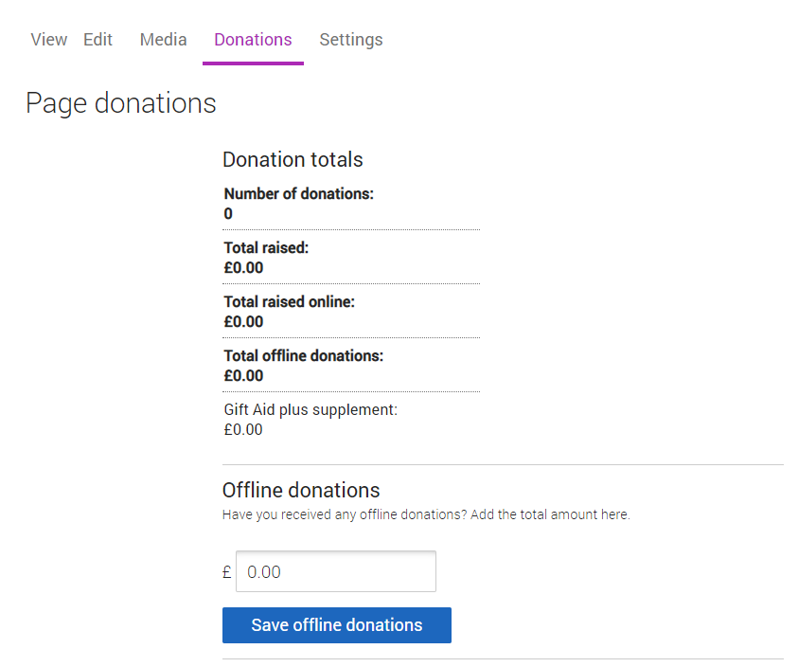
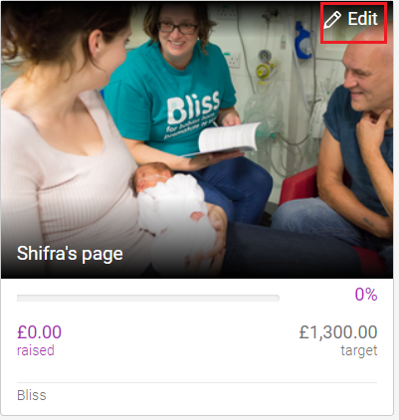
- Click 'Donations' at the top.
- Amend the total amount raised offline and select 'Save offline donations'.
If you’d like to acknowledge the friends and family who've given you money offline, you can add a quick update to your page thanking them for their donation.
PLEASE NOTE: Currently, offline donations on a Fundraising Page won't pull through to your Team Page, but we're working on making this possible in the future.

SOCIAL MEDIA CONTENT
Social media platforms such as Facebook, Twitter, Instagram, Google Plus, LinkedIn, and Pinterest are great communication channels. They will help you connect with your extended network in the lead up to your fundraising event..

SOME SAMPLE POSTS:
- We’re proud to announce we will be participating in this year’s Winter Warrior Games 2024. If you would like to support our fundraiser, please visit [Insert JustGiving fundraising page link].

- We’ve been fundraising for the [campaign name] – have you donated yet? Don’t forget to support [TeamName] at [Insert team link].

- Help us raise funds for @Wellspring Multi-Service Centers [Insert team link].

SOCIAL HANDELS
https://www.facebook.com/Wellspringmultiservice
https://www.instagram.com/wellspringmultiservice/
https://www.linkedin.com/company/wellspring-multi-service-center
FINAL THOUGHTS
Keep your supporters and team members excited and engaged in the days and months leading to event day. Now that you’re a Team Captain for our organization, use the next few months to get involved, learn more, share more, and make a difference for them.

Below are JustGiving’s top tips:
- Use this toolkit and resources to keep the mission of the organization you are fundraising for foremost in their minds. What they are doing matters!
- Help donors connect to the organization you are supporting by asking them to donate a specific amount and telling what this amount will do for the organization.
- Contact supporters who have helped you in previous years and ask them to donate again.
- Communicate regularly with your team members to provide each other with constant encouragement.
- Create “spiritwear” for your team or donors to wear.
- Feature your amazing supporters and team members on your social media channels to help recruit more donations.
- Organize group sessions and invite your supporters (or potential supporters) to join in with your team.
- Make a plan. Make it fun. "People rarely succeed unless they have fun in what they are doing.” - Dale Carnegie

SUPPORT
We hope this toolkit has provided you with good information you need to create excitement, increase donations, and ultimately make your team super successful. We’re here to help. Please feel free to reach out to us anytime.

Wellspring contact:
Jessie Pilewski, Advancement Coordinator
Email: jessie@wellspringmultiservice.org
Phone: 781-925-3211 ext 120
Website: https://wellspringmultiservice.org/

Fundraisers help hub: https://help.justgiving.com/hc/en-us
- Share our Fundraising Page Checklist
- Promote fun GIFs or social sharables that your supporters can repurpose to highlight progress towards their goal
- Individuals can receive step-by-step instructions to create a personal page, edit it, and use features like live video and fitness through our Fundraiser Resource Library.

